This is a paper on transport network reliability
(Times New Roman Bold 14pt)

Maria Andersson^{1*}, Karl E Johansson², Lars Nilsson¹

¹Division of Transport Planning, KTH Royal Institute of Technology, Sweden
²Division of Systems Analysis and Economics, KTH Royal Institute of Technology, Sweden
*Corresponding author: maria.andersson@abe.kth.se

Extended abstract submitted for presentation at the
8th International Conference on Transport Network Reliability (Stockholm, 24-26 June, 2020)

1. Introduction (Times New Roman Bold 11pt)

Please clearly describe the aim of the study and its contributions (Times New Roman 11 pt). All text should be outlined and single spaced. Please insert figures and tables like Figure 1 and Table 1. Section headers used in this extended abstract are merely examples.

The maximum length for extended abstracts is 2500 words (excluding Figures, Tables and Reference list). Authors that would like to use LaTeX are asked to follow this format as closely as possible (A4 paper size, margins are 1 inch = 2.54 cm on all sides).

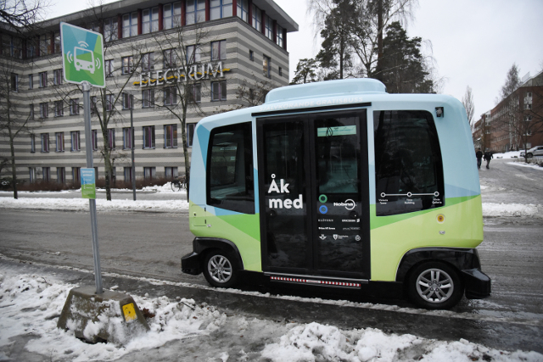
Figure 1: Automated bus in Kista, Stockholm (Times New Roman Italic 11pt)

2. Important dates and process (Times New Roman Bold 11pt)

All extended abstracts will be reviewed. Please submit your extended abstract by October 2019 in PDF format via EasyChair (details will be published on the conference website, www.instr2020.se). Authors of accepted extended abstracts will be invited to submit a revised extended abstract and (optionally) a full paper by March 2020.

Table 1: Flow, density, and speed (Times New Roman Italic 11pt)
 | Motorway M1 | Motorway M4 | Eastern Distributor
Traffic flow (veh/h)
Traffic speed (km/h)
Traffic density (veh/km)

3. Methodology (Times New Roman Bold 11pt)

Equations should be numbered in the usual way as in Equation (1),
(1)
Citations in the text and references at the end should conform to Harvard style. Running citations should be like Jenelius et al (2006).

4. Results and conclusions (Times New Roman Bold 11pt)

The extended abstract should preferably contain (preliminary) results of the study.

References

Jenelius, E., Petersen, T. and Mattsson, L.G. (2006). Importance and exposure in road network vulnerability analysis. Transportation Research Part A: Policy and Practice, 40(7), 537-560.
Jenelius, E. and Koutsopoulos, H.N. (2013). Travel time estimation for urban road networks using low frequency probe vehicle data. Transportation Research Part B: Methodological, 53, 64-81.

